* **Activity 5:**

Creating a Script

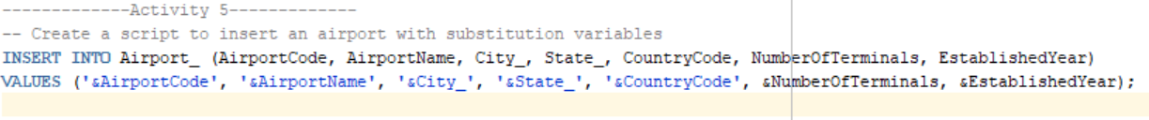

OUTPUT: